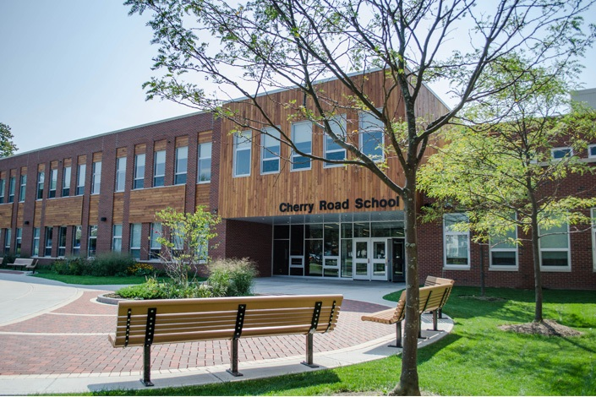

MINIMUM CAPACITY :-
The Minumum intake capacity
of students is between 850-1000
children

LIBRARY :-
The Libarary is Available.

CANTEEN:-
The Canteen Facility is Available.

BOARDING :-
No availablility of boarding.

SPORTS :-
There are different categories
sports available.
Girls Volleyball
Boys Volleyball
Football

WESTHILL CENTRAL SCHOOLS
SYRACUSE - SCHOOL

School Detail :-
Westhill Central Schools is a public school district immediately adjacent to the city of Syracuse, New York, USA, serving students primarily in the Town of Geddes and Town of Onondaga. The district is irregularly shaped with two large areas served joined by a narrow connection, as in the shape of an hourglass.
The student body at the schools served by Westhill Central School District is 82.8% White, 5.5% Black, 1.8% Asian or Asian/Pacific Islander, 4.7% Hispanic/Latino, 0.3% American Indian or Alaska Native, and 0.2% Native Hawaiian or other Pacific Islander. In addition, 4.7% of students are two or more races, and 0% have not specified their race or ethnicity.

